 | Particulars | SA | A | N | D | SD
1. | The admission process adopted by the College is effective. | 19 | 1 | 0 | 0 | 0
2. | The College is able to attract meritorious students. | 18 | 1 | 1 | 0 | 0
3. | Student centered learning resources are available in the College. | 20 | 0 | 0 | 0 | 0
4. | The faculty are updating their knowledge and skills. | 20 | 0 | 0 | 0 | 0
5. | The class work is taking place as per schedule. | 19 | 1 | 0 | 0 | 0
6 | The Central Library is a major source of information. | 18 | 2 | 0 | 0 | 0
7 | The procedure followed for acquiring new books and journals ensures maximum use of the library | 15 | 5 | 0 | 0 | 0
8 | The library is utilized optimally by the students. | 15 | 3 | 2 | 0 | 0
9 | The timings of the Library are convenient. | 14 | 6 | 0 | 0 | 0
10 | The procedure followed for acquiring new books and journals ensures maximum use of the library | 17 | 3 | 0 | 0 | 0
11 | The teaching aids in the department are sufficient and up to date. | 15 | 5 | 0 | 0 | 0
12 | The teachers are supported with adequate learning resources. | 20 | 0 | 0 | 0 | 0
13 | The teachers are encouraged to carry out research. | 18 | 2 | 0 | 0 | 0
14 | The teachers are encouraged to organize seminars/workshops/ symposia/conferences. | 17 | 2 | 1 | 0 | 0
15 | The teachers are encouraged to undertake extension service programmes. | 17 | 2 | 1 | 0 | 0
16 | The merit of the teachers is recognized. | 14 | 4 | 2 | 0 | 0
17 | The examination system followed by the college is effective. | 18 | 1 | 1 | 0 | 0
18 | The evaluation system followed by the college is effective. | 17 | 3 | 0 | 0 | 0
 | Total | 306 | 45 | 9 | 0 | 0
 | CHANDRAKETUGARH SAHIDULLAH SMRITI MAHAVIDYALAYA.  Berachampa, Debalaya, North 24 Parganas
FEEDBACK ANALYSIS: FACULTY 2021-22

I. TEACHING, LEARNING, EVALUATION & RESEARCH

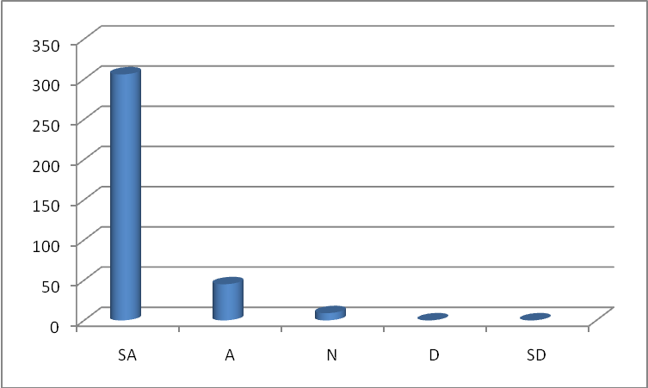
I. TEACHING, LEARNING, EVALUATION & RESEARCH

II. INFRASTRUCTURE

Particulars |  | SA | A | N | D | SD
1. | The class rooms and furniture available are adequate. | 17 | 2 | 1 | 0 | 0
2. | The toilets are sufficient for faculty and students. | 17 | 3 | 0 | 0 | 0
3. | The buildings and furniture are well maintained. | 18 | 1 | 1 | 0 | 0
4. | The labs are adequately equipped (wherever applicable). | 17 | 1 | 2 | 0 | 0
5. | The infrastructure available in the department is optimally used. | 19 | 0 | 1 | 0 | 0
6. | Parking facilities are available adequately. | 15 | 2 | 3 | 0 | 0
8. | Water resources are adequately provided. | 19 | 1 | 0 | 0 | 0
9. | Safe drinking water is available. | 20 | 0 | 0 | 0 | 0
10. | Sports infrastructure is adequate. | 17 | 2 | 1 | 0 | 0
 | Total

II. INFRASTRUCTURE
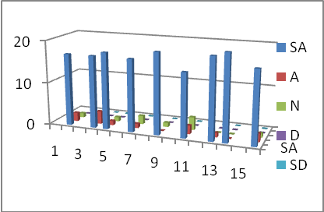

Particulars | SA | A | N | D | SD
1. The administration is sincerely putting efforts for the development of the institution. | 17 | 3 | 2 | 0 | 0
2. The administration is accessible to all faculty. | 18 | 2 | 0 | 0 | 0
3. The quality initiatives taken up during the last academic year are contributing for improvement. | 19 | 0 | 1 | 0 | 0
4. . The faculty are given freedom to express their opinions. | 20 | 0 | 0 | 0 | 0
5. The IQAC is working well for promoting quality in the institution. | 19 | 1 | 0 | 0 | 0

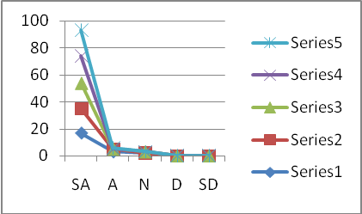

Regarding teaching learning no major grievance has been expressed by the teachers. There should be improvement on two sectors, namely the utilization of books by the students from the library and the proper availability of the teaching aids for the teachers. In infrastructure sports infrastructure and parking facilities need to be improve in the college campus. Regarding governance it seems that the faculty are all happy but efforts should be made to make the administration more access able to the faculty.

